**Azure SQL Server Database Export and Import Overview.**

Created: 15/08/2021

In this tutorial, I’m going to show how to:

* Export Azure Database through Azure Portal
* Export Azure Database through SQL Server Management
* Import Azure Database Backup file through Azure Portal
* Import Azure Database backup file through SQL Server Management

**Step 01: Export Azure Database through Azure Portal**

Under the existing Resource Group we have a SQL Server and a SQL Database.

* Resource group: Test_Environment1
* Azure SQL Server: myfirstsqlserver01
* Azure SQL Database: TestSQLdatabase

* I already created a Storage account and upload C# program codes to Blob Service.

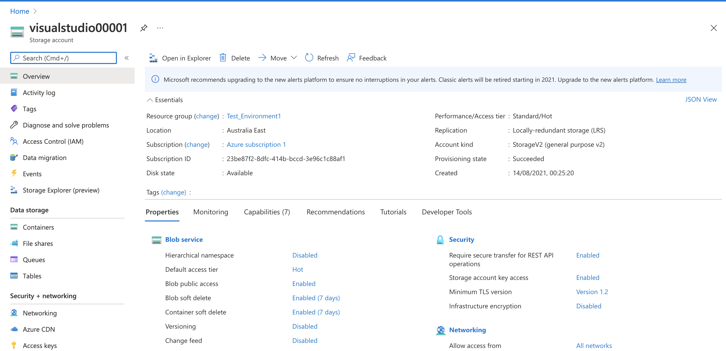

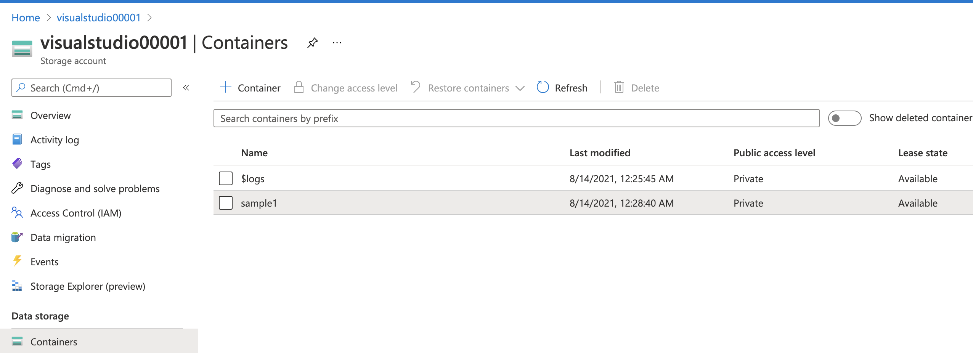

Uploaded C# code

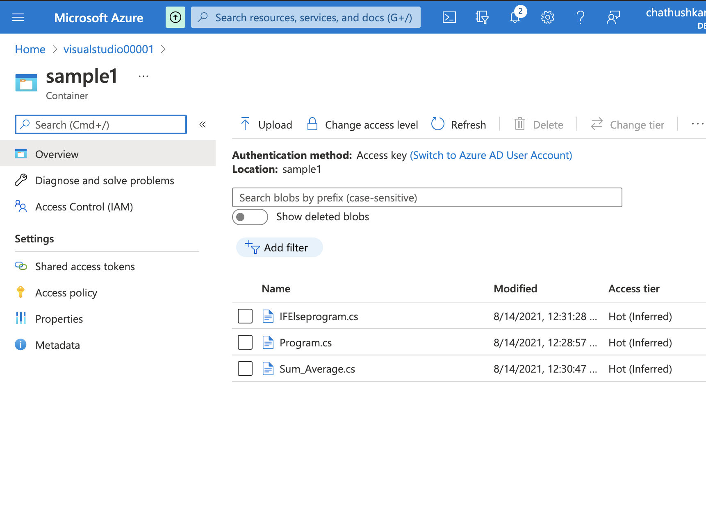

* Now Export the Database. Go to SQL Database and Click on Export button.

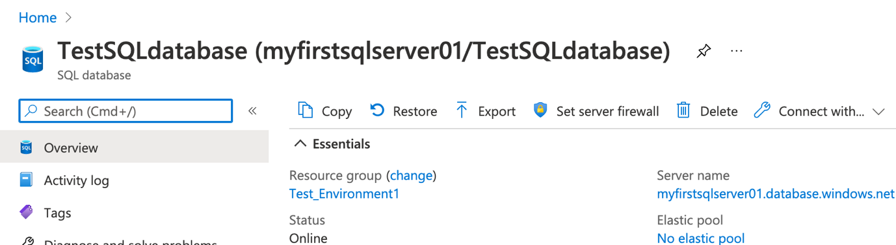

provide the relevant data.

* File name: TestSQLdatabase-2021-8-14-26
* Server admin Login/Password: Login details thaw we provided when creating the Database.
* Storage: Click “Configure Required Settings” and provide storage account details  
    
  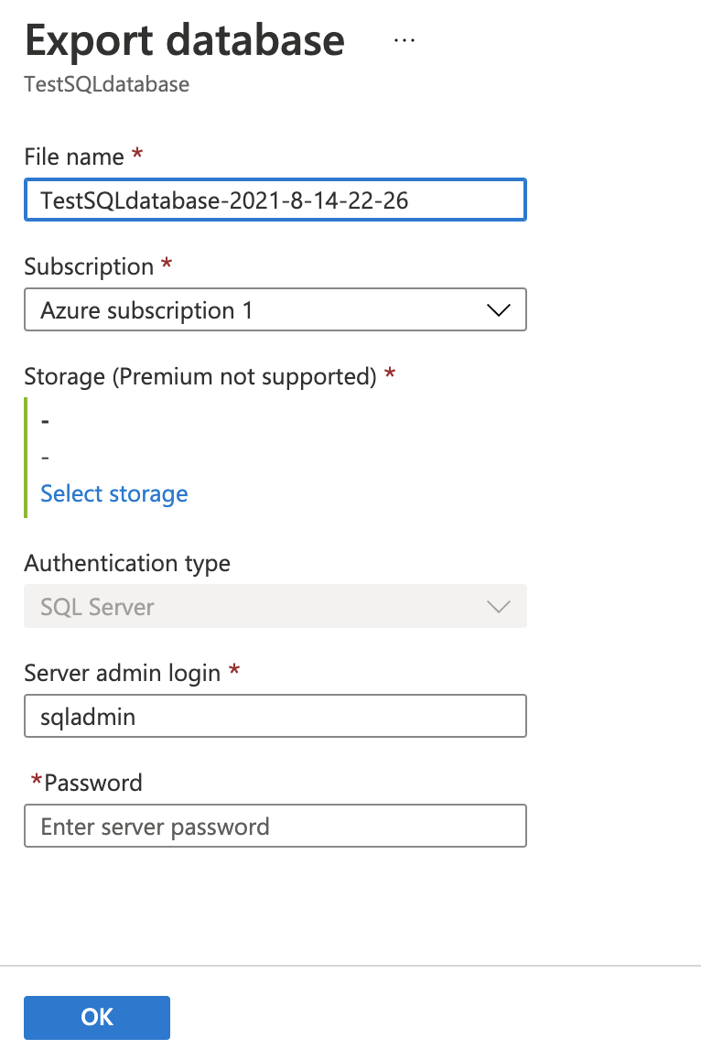

Storage Configuration:

* Click on “Configure Required Settings” and select the Storage Account that created earlier.

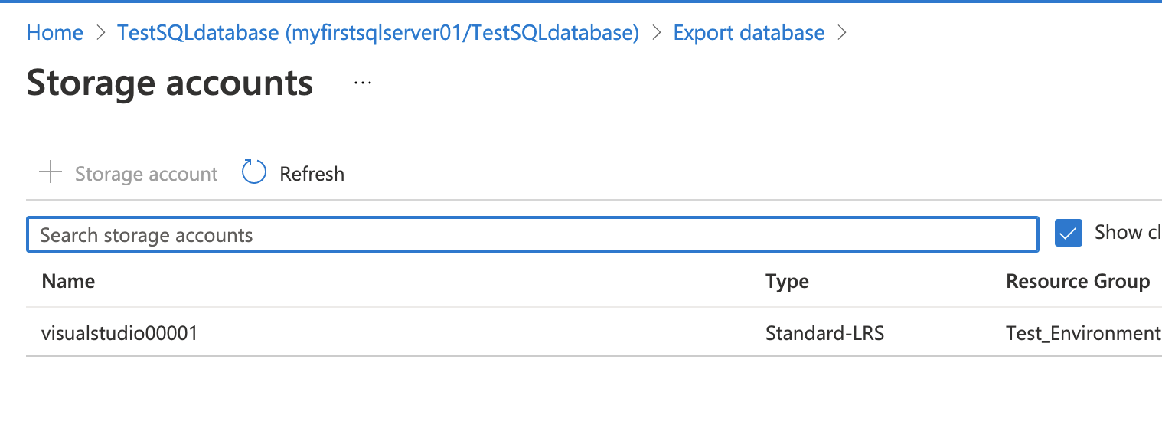

* Select the container that created earlier under the selected Storage Account.

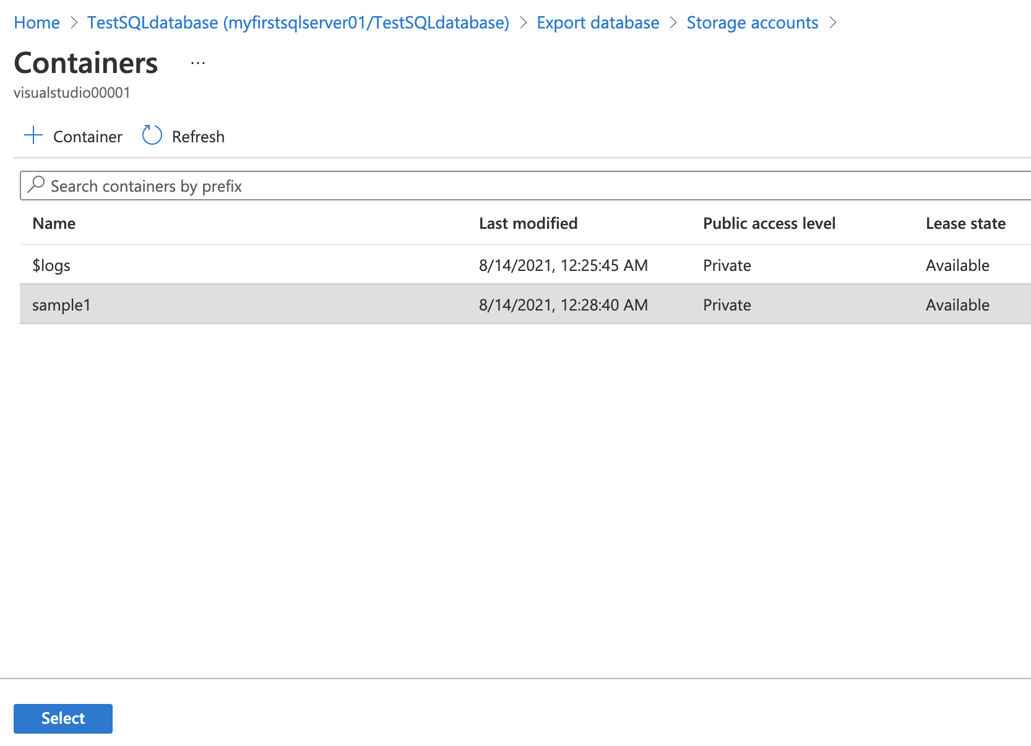

* Click Ok.

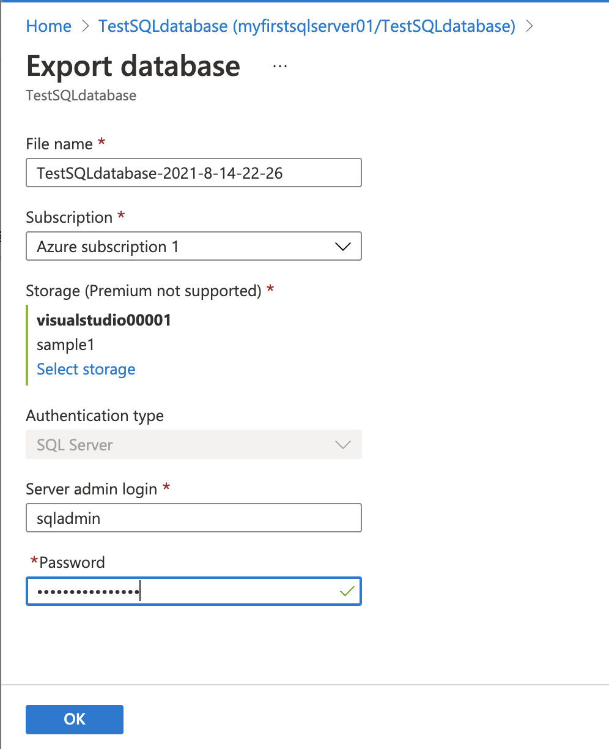

It will give a notification that showing request has been created for Exporting Database.

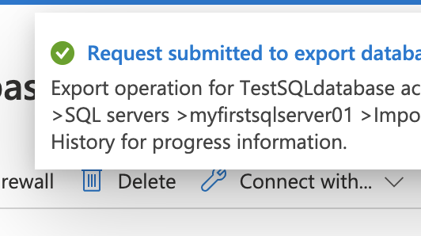

To check the progress of the Export, go to “Import/Export History” tab under the SQL Server instance, and check.

So, now it is in “Running” status. It will take some time to finish the Export.

**Step 02: Export Azure Database through SQL Server Management.**

Connect to SQL Server instance through SQL Server Management.

I have created a VM in Azure and download **Microsoft SQL Server Management Studio.**

* Server name: myfirstsqlserver01.database.windows.net
* Authentication: SQL Server Authentication
* Login/Password: Login/Password details should provide SQL Database Password

**

Right Click on the Database, Click on Tasks, Export Data-tier Application.

Right click on the Database, Click on Tasks, Export Data-tier-Application.

Click Next

Select Save to Microsoft Azure. In this case, Login to Microsoft Account and select storage account. Next image show that step.

It will take some time to export the data to the Storage Account. Once completed click close.

Once it complete exporting, Go to Storage Account and see the exported files.

